Assignment 12 - Research and the Web
Jenny Ferguson
fergie13@vt.edu
4/15/2011
€
My need was to determine the most effective instructional methodology based on student learning styles.

http://ascilite.org.au/ajet/ajet15/mcloughlin.html

The search term I used was: instructional methodology learning styles

This article is perfect for what I needed. I wanted an article that would give me some ideas as to what I could to enhance learning in my classroom using learning styles as the foundation. The article not only gives great ideas, but it also provides examples and templates for strategies that can be used in the classroom. For example, one idea was to offer part of lesson using “dual mode,” so that the learner can choose the learning style in which they use. The article included the image below, which I used to showcase this point. In this case (Figure 4), the learner can choose to organize his thoughts, while others receive visual stimulation, and it is also concrete for those that need physical information.

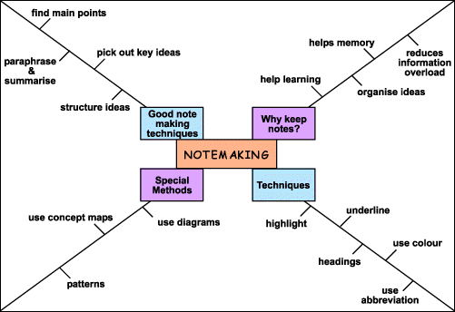
Figure 4: Advance organiser used to present a visual overview of learning material

